|  |  |
| --- | --- |
|  | **YEAR 12 MATHEMATICS SPECIALIST**  **SEMESTER ONE 2017**  **QUESTIONS OF REVIEW 3:**  **Vectors in 3 dimensions** |

Name: _______________________

Thursday 11th May Time: 40 minutes Mark /30

Calculator allowed.

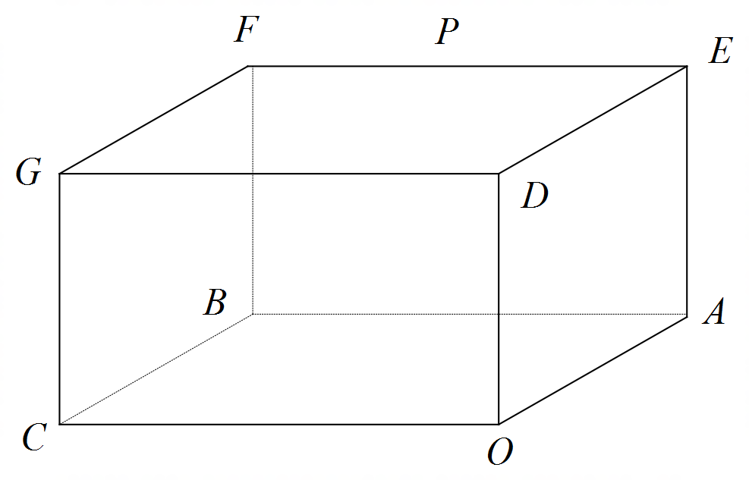

### [6 marks – 1, 1, 2 and 2]

The right rectangular prism shown has vertices , ,  and .

Use appropriate vector methods to represent:

#### the position of point *G*

#### the position of point *P*, the mid-point of *EF*

#### an equation for the line through points *C* and *P*

#### the angle the line *CP* makes with the base *OABC*

### [5 marks – 2 and 3]

### Use and the vectors and to calculate

#### the area of Δ*OAB*

#### 

### [8 marks – 1, 3, 2, 1 and 1]

#### Express the vector equation in Cartesian form

#### Calculate the point(s) of intersection of and

#### Describe, by a suitable vector or algebraic equation, the locus of points that are equidistant from the points of intersection found in (b)

#### Show that is a part of a diameter of

#### Calculate the distance between any pair of parallel planes tangential to opposite sides of

### [7 marks – 2, 2 and 3]

### The vector is perpendicular to the plane , which is itself parallel to both and .

#### Use scalar (dot) product calculations to set up equations sufficient to evaluate *a* and *b*

#### Use a vector (cross) product calculation to set up an equation to evaluate *a* and *b*

#### Solve for *a* and *b* and hence develop a Cartesian equation for , which passes through

### [4 marks]

The position vectors of three non-collinear points *A*, *B* and *C*, with respect to an origin *O*, are ,  and  respectively.

*O* does not lie in the plane *ABC*.

The point *Q* with position vector  does lie in the plane *ABC*.

Show that 

#### **Formulae:**

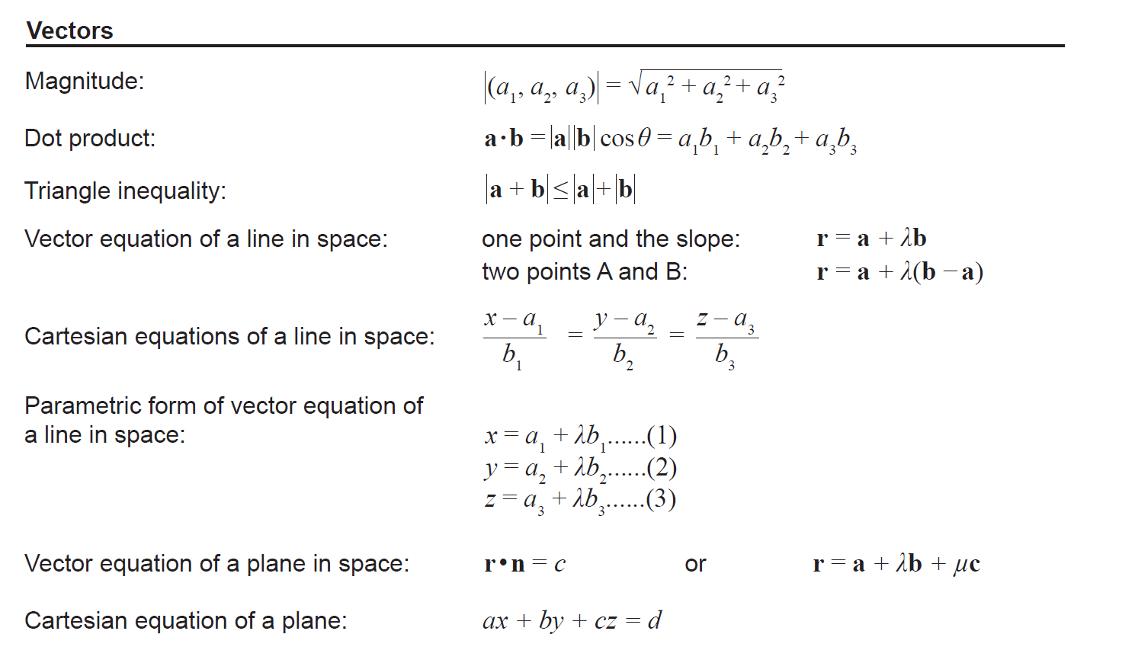

Vector cross product  and 

The sphere defined by  has a centre with position vector  and radius *k*